**Check whether the character is vowel**

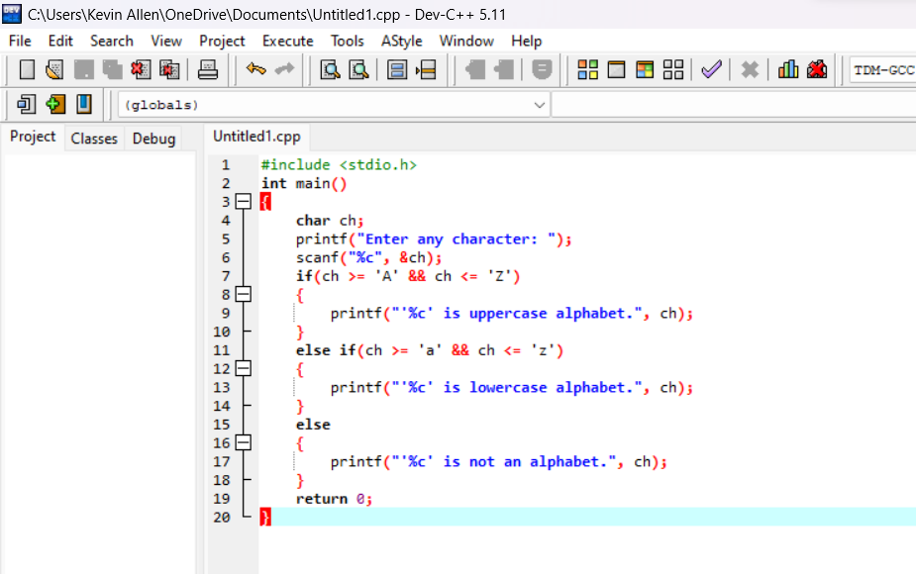

**Output**

